**CASE STUDY ON**

**“ONLINE RAILWAY RESERVATION SYSTEM”**

**Submitted By:**

**GROUP-2(BULT .NET SNEHAL)**

**CAPGEMINI**

**REPORT CONTENTS**

1. OBJECTIVE
2. INTRODUCTION
3. TECHNOLOGY (TOOLS AND TECHNIQUES)
4. SOFTWARE REQUIREMENT SPECIFICATION
5. DIAGRAMS
   1. USECASE DIAGRAM
   2. CLASS DIAGRAM
   3. SEQUENCE DIAGRAM
   4. E-R DIAGRAM
   5. STATE CHART DIAGRAM
6. FUTURE SCOPE

****1.OBJECTIVE****

To develop software for railway reservation system with various functional and non-functional part of design namely,

* PROBLEM ANALYSIS AND REQUIREMENT ANALYSIS.
* TRAIN ENQUIRY
* TICKET GENERATION
* TICKET CANCELLATION

**GOAL:**

The goal of this project is to develop a database that integrates the process of the Reservation of railway.

**2.INTRODUCTION**

The purpose of this source is to describe the railway reservation system which provides the train timing details, reservation, billing and cancellation on various types of reservations namely, Train available between a pair of stations.

* Confirm Reservation for confirm Seat.
* Reservation against Cancellation.
* Reservation status.
* Online Reservation
* PNR Generation.

**It consists of:**

* Train details
* Reservation form
* Billing
* Cancellation.

**3. TECHNOLOGY USED**

USER INTERFACE:

* Keyboard and Mouse

HARDWARE REQUIREMENT:

* Printer
* Normal PC
* CPU – Intel Core I5
* RAM – 16GB (MIN)
* Hard Disk – 8GB
* Operating System(64-bit) – Windows 10 (1145G7)

**4. SOFTWARE REQUIREMENT**

**Frontend**: - HTML, CSS, REACTJS.

**Backend**: - MVC.net framework.

**Database: -** SSMS (SQL server management studio).

**GENERAL DESCRIPTION**

**PRODUCT PERSPECTIVE**

It enables us to maintain the railway train details like their timings, number of seat available and reservation billing and cancelling the tickets.

**OPERATIONS**

* One form for 6 persons only.
* Payment is full fare for adult and children.
* No advance booking for general and ladies quota.
* Payment is accepted in credit and debit cards.

**TRAIN DETAILS**

Customers may view the train timing at a date their name and number of tickets.

**RESERVATION**

After checking the number of seats available the customers reserve the tickets.

**BILLING**

After reserving the required amount of tickets, the customer paid the amount.

**CANCELLATION**

If the customers want to cancel the ticket.

**CONSTRAINTS**

* There is no maintainability of back up so availability will get affected.
* Real-life credit card validation and Banking system is not implemented.
* No multilingual support.

# Administrator

**Database Management:** Control the database and keep track of all records of customers.

**View all details:** View the details of all orders and control the whole application.

**Update**: Update train details

**Customers:**

**Login:** Customers must have a valid login id (PNR number) to enter into the site.

**Registration:** New users can sign up by creating new ID.

**Cancellation:** Cancel the ticket any time.

**View:** View train details.

**SOFTWARE SYSTEM ATTRIBUTES**:

* Reliable
* Available
* Secure

**5. DIAGRAMS**

**a.Use Case Diagram**

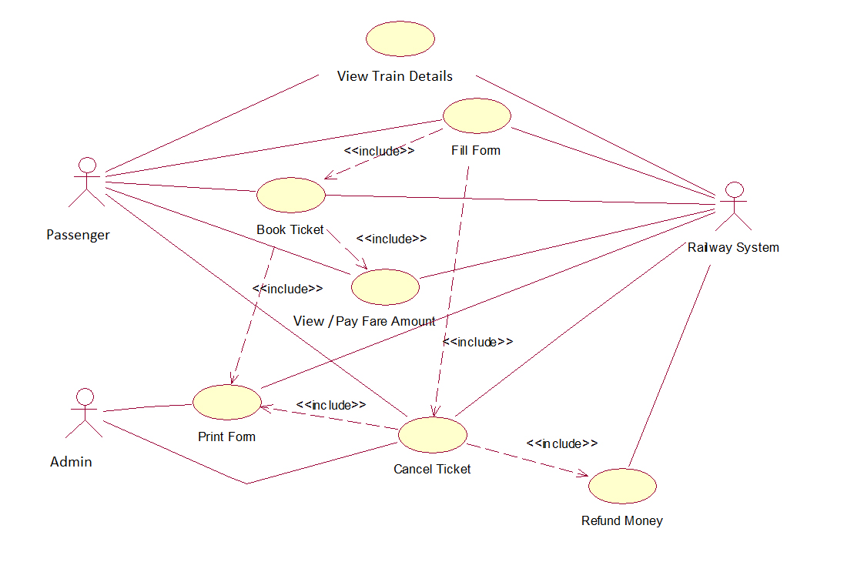

**b.Class Diagram**



**c.Sequence Diagram**

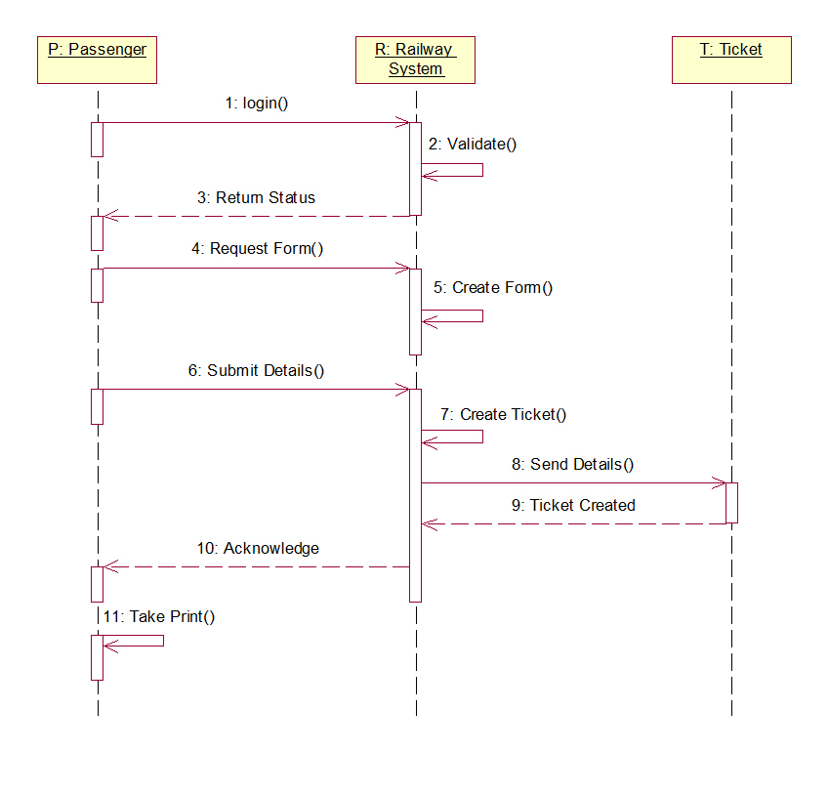

**d.ER Diagram**

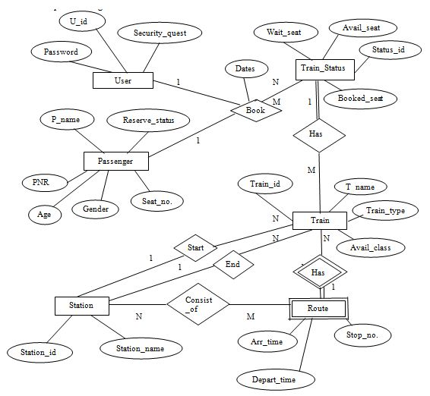

**e.State Chart Diagram**

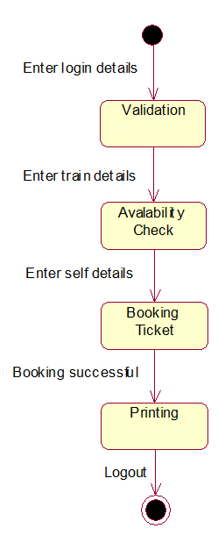

6.FUTURE SCOPE

* Improved & optimized service.